MUHAMMAD AHMAD RAZA

476253

LABTASK 6

TASK 1

#include<iostream>

using namespace std;

int main() {

int prev,current,next,terms,i,j;

cout<<"Enter number of terms: ";

cin>>terms;

cout<<" "<<endl;

cout<<"Fibonacci sequence of "<<terms<<" terms:-"<<endl;

for(i=0;i<terms;i++)

{

prev=0;

current=1;

for(j=0;j<=i;j++)

{

cout<<prev<<" ";

next=prev+current;

prev=current;

current=next;

}

cout<<" "<<endl;

}

return 0;

}

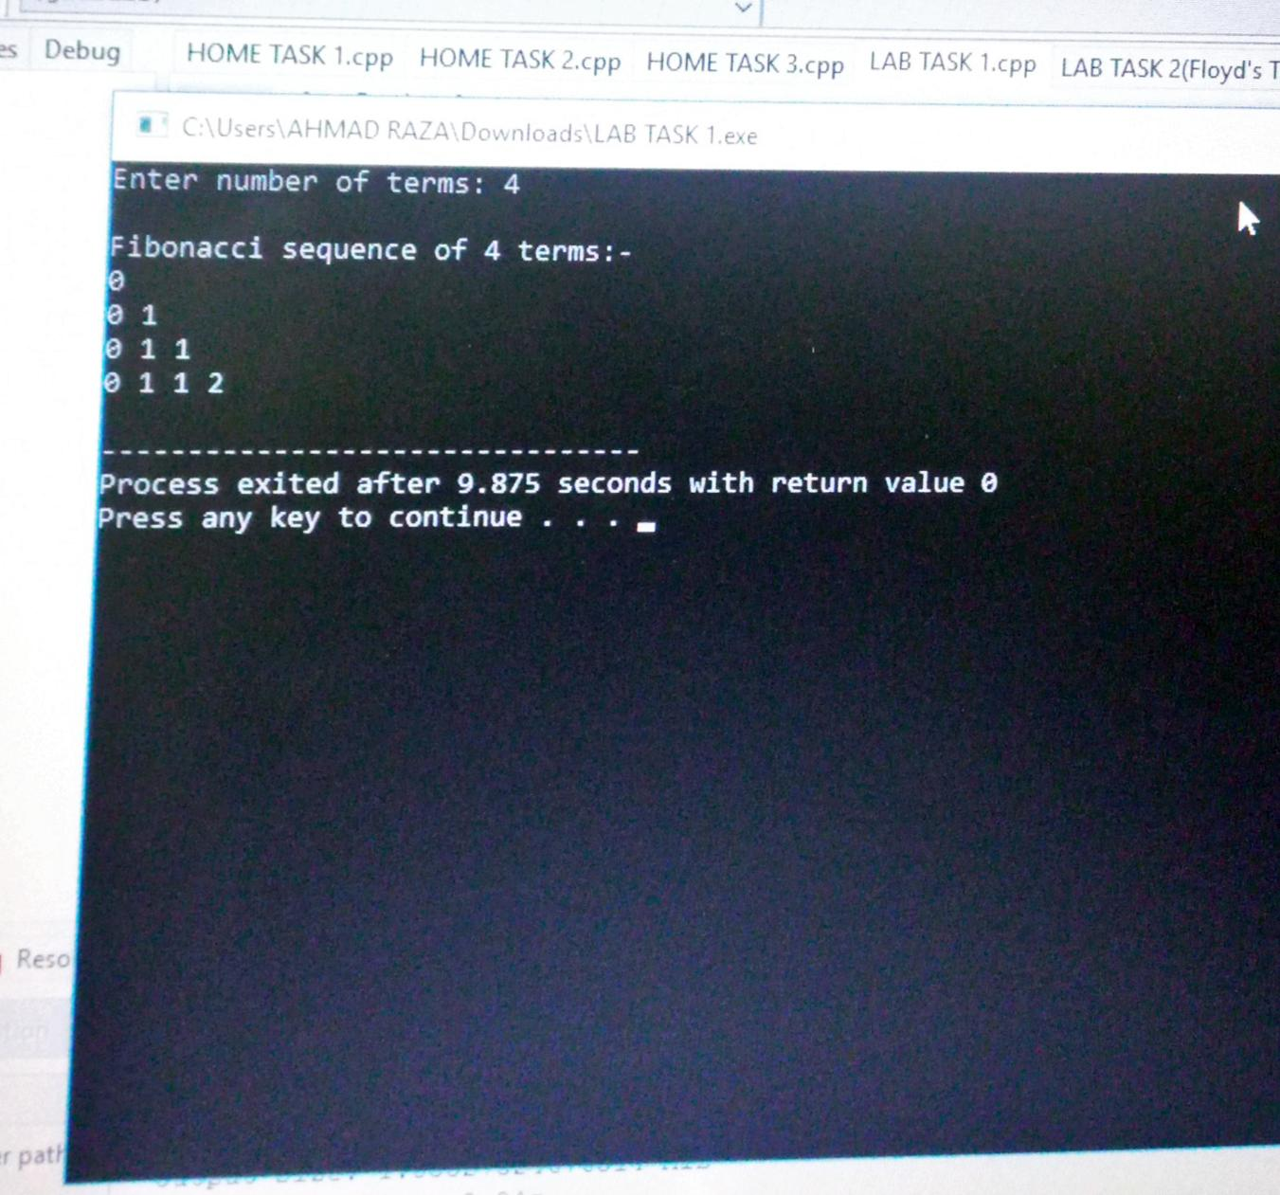

TASK 2

#include<iostream>

using namespace std;

int main() {

int n,sum,i,j;

n=0;

sum=1;

for(i=0;i<10;i++)

{

if(i<=4)

{

for(j=0;j<i;j++)

{

cout<<sum<<" ";

sum++;

}

}

else

{

for(j=0;j<i;j++)

{

cout<<sum<<" ";

sum++;

}

}

cout<<endl;

}

}

